Ideation Phase Empathize&Discover

|  |  |
| --- | --- |
| Date | 19June2025 |
| TeamID | LTVIP2025TMID60646 |
| ProjectName | Visualizinghousingmarkettrends:ananalysis of sales prices and features using tableau |
| MaximumMarks | 4Marks |

**EmpathyMapCanvas:**

An empathy map is a simple, easy-to-digest visual that captures knowledge about a user’s behaviours and attitudes.

Itisausefultooltohelpsteamsbetterunderstandtheirusers.

Creating an effective solution requires understanding the true problem and the person who is experiencing it. The exercise of creating the map helps participants consider things from the user’s perspective along with his or her goals and challenges.

Example:



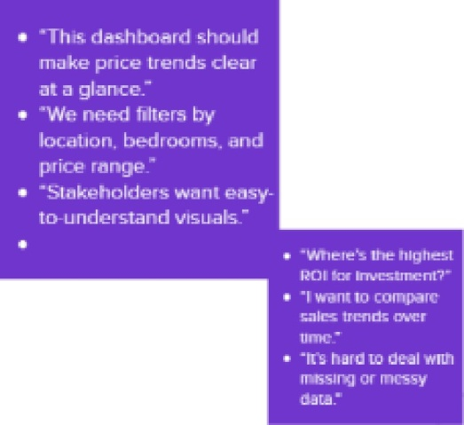o”HopeoshelpsOnerriaietiigce

wa'yovisualizeneliplofeafiJres*“

ThinKs

+°AmIenolyzlrsg1henghłvor*abIes?"

<“Fanispoteartyslgnsof

marł<etchanges*“

o"flowc0nImekemg

interanw?”'

* 'I nc• do buiid conFldenceInlheseirsiqhŁs"



* + Bu lds hsatmeps, bor chorto, and trend lines in Tableau

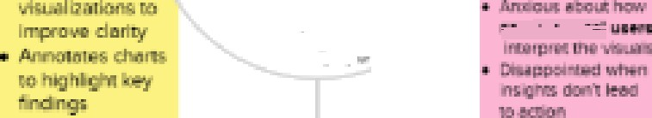

*Applics fi|ters yo explore regionalor fealure•based price trenÓs

+Sharesdashboardswith

gtąkehCilders

* + Cleansansp•epsdata

defotcimponinqto

eWorriedaboutdata

qualityormissingvalues

* + *fleet*pres*sureia*deliver quickbutde«pinsieh\s

+Frustrated when Tableau charts done behave es expected

